11/15/2020

Friends of The Kickapoo Valley Reserve
Board of Directors Meeting
Monday, November 16, 2020
5:00 P.M. at KVR Visitor Center

Call to Order

Secretary’s Report and approval

Treasurer’s Report and approval

Old Business

New Business

Committee reports
Photo contest
Cookie walk/bread sale/wreath sale event status

Future meetings on Zoom (or equivalent)

Set next meeting date. Currently set for Monday, December 21, 5:00pm at VC
Is a December meeting necessary?
Adjourn

Donation level names
On website:
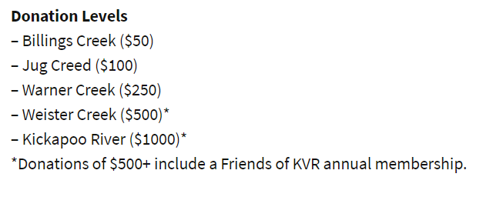
On envelope:
Enhanced Discovery Center
Property Restoration/Recreation Management
Environmental Education Program
General Donation

